Database Application Design Document

Project Name:

Newspaper/Magazines Delivery Management Program

Project Team Members:

Wei Wu

Creation Date:

5/19/2016

Revision History:

**1. Introduction**

Purpose of this document

This is a design document…

It was realized by Wei Wu for Project Newspaper Delivery System

The program allows a business to keep track of households (customers), publications (The newspaper company), and carriers (the delivery guy).

**2. Architecture Design**

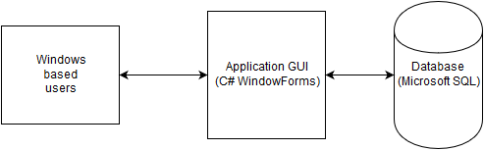

**3. Database Design**

The data used by the software will be stored in the local Microsoft SQL Database

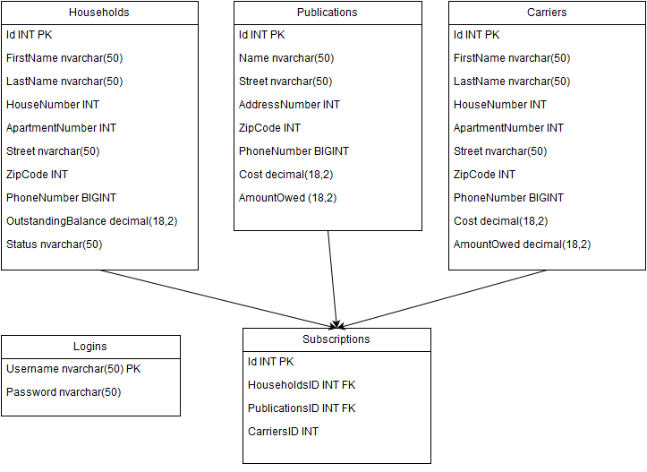

**3.1 Entity-Relationship Diagram** **– Business Data Model**

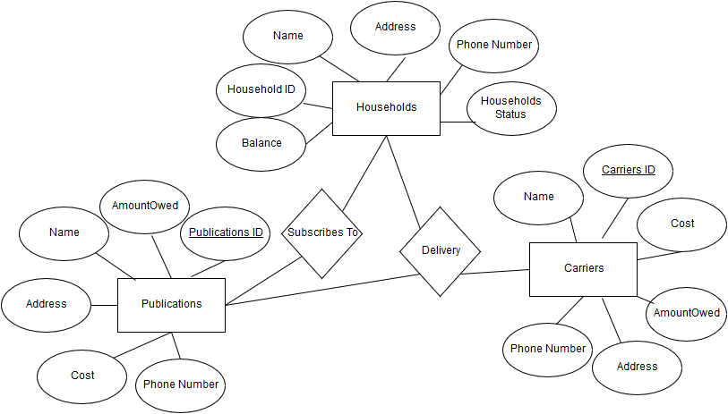

**3.2 Relational Data Model**

*Households (Id, FirstName, LastName, HouseNumber, ApartmentNumber, Street, ZipCode, PhoneNumber, OutstandingBalance, Status)*

*Publications (Id, Name, Street, AddressNumber, ZipCode, PhoneNumber, Cost, AmountOwed)*

*Carriers (Id, FirstName, LastName, Street, HouseNumber, ApartmentNumber, ZipCode, PhoneNumber, Cost, AmountOwed)*

*Subscriptions (HouseholdsID, PublicationsID, CarriersID)*

# 3.3 Logical Schemas

|  |  |  |  |
| --- | --- | --- | --- |
| Households |  |  |  |
| **Description** | This table describes a households information | | |
| **Attribute** | **Description** | **Type** | Examples of values |
| Id | The Id of the household in the database | Integer | 9 digit between 000000001 and 999999999 |
| FirstName | The First name of the head of the household | String | Bob |
| LastName | The Last name of the head of the household | String | Tom |
| HouseNumber | The address number | Integer | 9 digit between 000000001 and 999999999 |
| ApartmentNumber | The apartment number if there is one | Integer | 9 digit between 000000001 and 999999999 |
| Street | The street of the address | String | Castle Ave |
| ZipCode | The zip code of the address | Interger | 103001 |
| PhoneNumber | The houses phone number | Interger | 9179991111 |
| OutstandingBalance | The amount the household owns to the company | Double (precision 2) | 23,345.00 |
| Status | The current status of the households account | String | Active/Suspended |
| Primary Key | Id | | |
| Foreign Keys |  | | |
| Sample SQL Code |  | | |
|  |  | | |

|  |  |  |  |
| --- | --- | --- | --- |
| Publications |  |  |  |
| **Description** | This table describes a publications information  ex: New York Times | | |
| **Attribute** | **Description** | **Type** | Examples of values |
| Id | The Id of the publication in the database | Integer | 9 digit between 000000001 and 999999999 |
| Name | The name of the publication | String | New York Times |
| AddressNumber | The address number | String | 9 digit between 000000001 and 999999999 |
| Street | The street of the address | String | Castle Ave |
| ZipCode | The zip code of the address | Interger | 103001 |
| PhoneNumber | The publications phone number | Interger | 9179991111 |
| Cost | The price of subscribing to the publication | Double (precision 2) | 23,345.00 |
| AmountOwed | The amount the delivery company owes to the publication | Double (precision 2) | 23,345.00 |
| Primary Key | Id | | |
| Foreign Keys |  | | |
| Sample SQL Code |  | | |
|  |  | | |

|  |  |  |  |
| --- | --- | --- | --- |
| Carriers |  |  |  |
| **Description** | This table describes a carriers information  Ex: UPS, USPS, FedEx | | |
| **Attribute** | **Description** | **Type** | Examples of values |
| Id | The Id of the carrier in the database | Integer | 9 digit between 000000001 and 999999999 |
| FirstName | The First name of the carrier | String | Bob |
| LastName | The Last name of the carrier | String | Tom |
| HouseNumber | The address number | Integer | 9 digit between 000000001 and 999999999 |
| ApartmentNumber | The apartment number if there is one | Integer | 9 digit between 000000001 and 999999999 |
| Street | The street of the address | String | Castle Ave |
| ZipCode | The zip code of the address | Interger | 103001 |
| PhoneNumber | The phone number of the carrier | Interger | 9179991111 |
| Cost | The Amount the carrier will charge for delivery | Double (precision 2) | 23,345.00 |
| AmountOwed | The amount the delivery company owes to the carrier | Double (precision 2) | 23,345.00 |
| Primary Key | Id | | |
| Foreign Keys |  | | |
| Sample SQL Code |  | | |
|  |  | | |

|  |  |  |  |
| --- | --- | --- | --- |
| Subscriptions |  |  |  |
| **Description** | This table describes the subscriptions. | | |
| **Attribute** | **Description** | **Type** | Examples of values |
| Id | The Id of the subsciption in the database | Integer | 9 digit between 000000001 and 999999999 |
| HouseholdsID | A FK to the householdsID | Integer | 9 digit between 000000001 and 999999999 |
| PublicationsID | A FK to the PublicationsID | Integer | 9 digit between 000000001 and 999999999 |
| CarriersID | The CarriersID | Integer | 9 digit between 000000001 and 999999999 |
| Primary Key | Id | | |
| Foreign Keys | HouseholdsID, PublicationsID | | |
| Sample SQL Code |  | | |
|  |  | | |

|  |  |  |  |
| --- | --- | --- | --- |
| Logins |  |  |  |
| **Description** | This table describes login accounts | | |
| **Attribute** | **Description** | **Type** | Examples of values |
| Username | The accounts username | String | Admin |
| Password | The accounts password | String | Password1 |
| Primary Key | Username | | |
| Foreign Keys |  | | |
| Sample SQL Code |  | | |
|  |  | | |

**4. Graphical User Interface**

